**Module 3 Quiz**

**TOTAL POINTS 10**

1.

Question 1

Based on the network below, what is the degree centrality of node D?

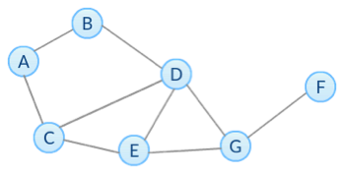

0.50

0.67

0.57

0.42

1 point

2.

Question 2

Based on the network below, what is the closeness centrality of node G?



0.75

0.6

0.875

0.7

1 point

3.

Question 3

Based on the network below, what is the normalized betweenness centrality (excluding endpoints) of node G?



0.67

0.33

0.24

0.47

1 point

4.

Question 4

Based on the network below, what is the betweenness centrality without normalization of edge (G,F)?



4

5

6

7

1 point

5.

Question 5

Select all True statements.

The node with highest betwenness centrality in a network also has the highest closeness centrality.

In directed networks, in-degree and out-degree centrality of a node are always the same.

The closeness centrality of a node describes how far the node is from others.

The assumption of degree centrality is that important nodes have more connections.

We can use subsets of node-pairs to approximate betweenness centrality.

1 point

6.

Question 6

Select all True statements about Page Rank (PR) and HITS in directed networks.

Adding out-links of a node will always decrease its PR.

Adding in-links of a node will never decrease its PR.

Nodes with high in-degree centrality have higher PRs than nodes with low in-degree centrality.

Nodes that have outgoing edges to good hubs are good authorities, and nodes that have incoming edges from good authorities are good hubs.

The authority and hub score of each node is obtained by computing multiple iterations of HITS algorithm and both scores of most networks are convergent.

1 point

7.

Question 7

Given the network below, which value of alpha (damping parameter) listed below in the NetworkX function pagerank maximizes the PageRank of node D?



0.8

0.5

0.9

0.95

1 point

8.

Question 8

Based on the network below, what is the basic PR of node C at step k = 1?

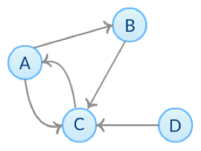

0.375

0.125

0.25

0.625

0.5

1 point

9.

Question 9

Based on the network below, what are the corresponding normalized authority and hub scores of node C correspondingly after two iterations of HITS algorithm?



0.33, 0.33

0.4, 0.4

0.57, 0.09

0.8, 0.2

1 point

10.

Question 10

Based on the network below, which of the following is NOT True? Check all that apply.



Node D’s basic PR at step k (k>=1) is always 0.

Node D’s authority and hub score after k iterations (k>=1) are always 0.

At each step, the sum of all nodes’ basic PR is always 1.

At step k (k>=1), node A’s basic PR is always the same as node C’s basic PR at step k-1.

1 point

I, **Ajit Pandey**, understand that submitting work that isn’t my own may result in permanent failure of this course or deactivation of my Coursera account. Learn more about Coursera’s Honor Code